WIDE BAND
2-WAY COMBINER / SPLITER

specification :
- frequency range: 2 – 5.75 GHz
- return loss : 15 dB min @ 2 split ports , typ @ combine port.
- insertion loss : 3.6 dB max @ < 2.5 GHz
4.4 dB max @ < 5.75 GHz
- isolation : 20 dB min @ < 2.5 GHz
15 dB min @ < 5.7.5 GHz
2004 / 7 / 30
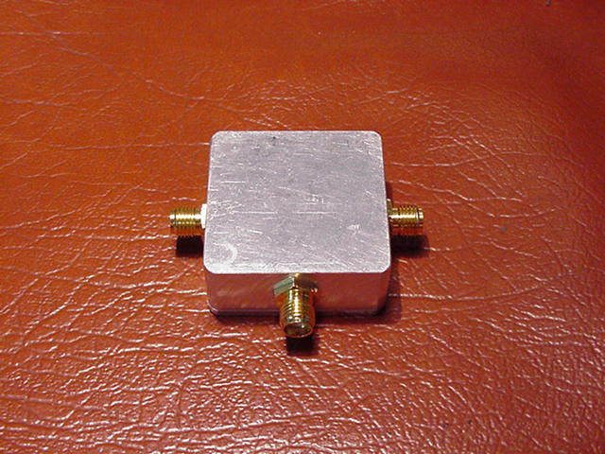
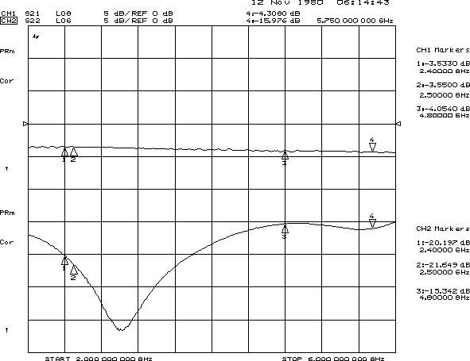
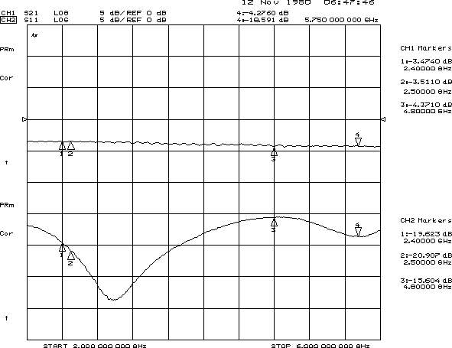
the R.L. and I.L. of 2 splitering ports

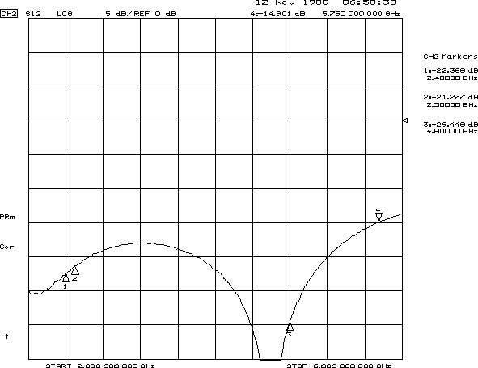
the isolation between 2 splitering ports

the R.L. of combining port
